Photosynthesis – Transforming Light into Life

Every breath you take is made possible by a chemical reaction you cannot see. The oxygen in your lungs was released by a plant, an alga, or a cyanobacterium somewhere on this planet. The food you ate for breakfast — whether toast, rice, fruit, or cereal — was once built from sunlight, water, and air. Yet most people never stop to think about the single most important chemical reaction on Earth.
Photosynthesis is the foundation of almost every ecosystem. It is the process that fills the atmosphere with oxygen, removes carbon dioxide, and produces the organic molecules that feed the entire living world. This reading material explores the chemical reaction of photosynthesis, the balanced equation that describes it, the key processes of light-dependent and light-independent reactions, and how photosynthesis helps reduce carbon dioxide levels in the environment.

Part 1: What Is Photosynthesis and Why Does It Matter?

Definition of Photosynthesis
Photosynthesis is the chemical reaction that transforms light energy (from the sun) into chemical energy stored in organic molecules (glucose). Autotrophs — plants, algae, and cyanobacteria — perform photosynthesis using the organelles called chloroplasts (in eukaryotes) or specialized membranes (in prokaryotes).

The Central Idea: Light Energy Becomes Chemical Energy
Light energy is a form of electromagnetic radiation. It travels from the sun to Earth. Plants capture this energy using chlorophyll and other pigments. They then convert it into chemical energy stored in the bonds of glucose. When organisms break down glucose (through cellular respiration), that stored chemical energy is released as ATP to power cellular work.

Why Photosynthesis Matters
Aspect | Explanation
Energy for life | Almost all organisms ultimately depend on photosynthetic  organisms for energy
Oxygen production | Photosynthesis releases the oxygen that animals and other  heterotrophs breathe
Carbon dioxide removal | Photosynthesis pulls CO₂ from the atmosphere, helping regulate  climate
Food production | All crops and agricultural products depend on photosynthesis
Fossil fuels | Coal, oil, and natural gas are ancient photosynthetic organisms

Part 2: The Balanced Chemical Equation for Photosynthesis
Photosynthesis converts carbon dioxide (CO₂) and water (H₂O) into glucose (C₆H₁₂O₆) and oxygen (O₂) using light energy.

The Balanced Equation:


Light energy + Carbon dioxide + Water → Glucose + Oxygen

Breaking Down the Equation
Component | Chemical Formula | Source | Role
Carbon dioxide | CO₂ | Atmosphere (enters through leaf stomata) | Carbon source for building glucose
Water | H₂O | Soil (absorbed by roots) | Source of electrons and hydrogen atoms; also releases oxygen
Light energy | Sunlight | Sun | Provides energy to drive the reaction
Glucose | C₆H₁₂O₆ | Produced by the plant | Stores chemical energy; building block for other organic molecules
Oxygen | O₂ | Released as a waste product | Used by heterotrophs for cellular respiration

What the Equation Tells Us
Observation | Meaning
6 molecules of CO₂ are used | For every glucose molecule, six carbon atoms are fixed from  the air
6 molecules of H₂O are used | Water provides electrons and hydrogen; it is split during the  light-dependent reactions
Light energy is written on the left | Energy is an input (not a chemical reactant, but a  requirement)
Oxygen is released | The oxygen atoms from water combine to form O₂ gas
Glucose is produced | Inorganic carbon (CO₂) becomes organic carbon (C₆H₁₂O₆)

Part 3: The Two Key Processes of Photosynthesis
Photosynthesis occurs in two main stages: the light-dependent reactions and the light-independent reactions (Calvin cycle) . The diagram below shows how they work together.

Process 1: Light-Dependent Reactions
The light-dependent reactions occur in the thylakoid membrane of the chloroplast and require direct sunlight. When light strikes chlorophyll and other pigments, the energy excites electrons to a higher energy level. These high-energy electrons are passed along an electron transport chain, and their energy is used to pump hydrogen ions into the thylakoid space, creating a gradient. As hydrogen ions flow back across the membrane through ATP synthase, ATP is produced.
Meanwhile, water molecules are split to replace the lost electrons, releasing oxygen as a waste product. Light also excites electrons in photosystem I, which are used to produce NADPH. The main outputs of the light-dependent reactions are ATP, NADPH, and oxygen (O₂).

Process 2: Light-Independent Reactions (Calvin Cycle)
The light-independent reactions, also known as the Calvin cycle, occur in the stroma (the fluid-filled space) of the chloroplast and do not directly require light. However, they depend on the ATP and NADPH produced by the light-dependent reactions. The cycle begins when carbon dioxide (CO₂) from the atmosphere is attached to a five-carbon molecule called RuBP in a process called carbon fixation.
The resulting six-carbon molecule immediately splits into two three-carbon molecules. Using energy from ATP and electrons from NADPH, these three-carbon molecules are converted into a three-carbon sugar called G3P. Some G3P molecules are used to build glucose and other organic compounds, while the remaining G3P molecules are recycled to regenerate RuBP so the cycle can continue. The main output of the Calvin cycle is CH₂O (a carbohydrate unit; six of these combine to form glucose, C₆H₁₂O₆).

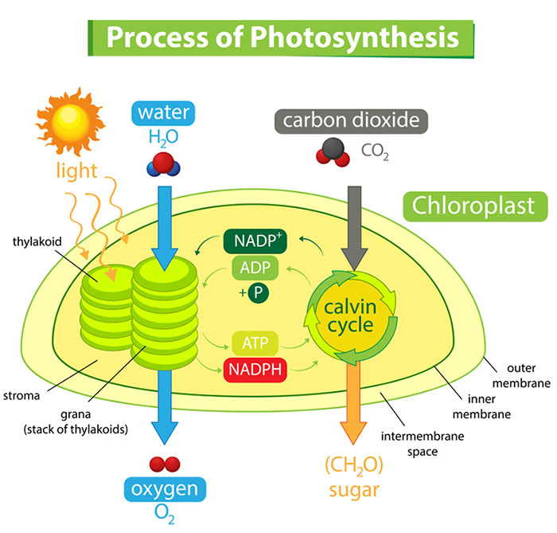

Part 4: Comparison of the Two Stages
Feature | Light-Dependent Reactions | Light-Independent Reactions  (Calvin Cycle)
Location in chloroplast | Thylakoid membrane | Stroma (fluid)
Requires light? | Yes | No (but needs products from light  reactions)
Inputs | Light, H₂O, ADP, NADP⁺ | CO₂, ATP, NADPH
Outputs | O₂, ATP, NADPH | CH₂O (glucose), ADP, NADP⁺
Role of chlorophyll | Captures light energy and excites electrons | No direct role
Energy source | Light directly | ATP and NADPH

Part 5: How Photosynthesis Helps Reduce Carbon Dioxide Levels in the Environment
Scientists use data from atmospheric monitoring stations, satellite observations, and controlled experiments to evaluate the impact of photosynthesis on CO₂ levels. The evidence is clear: photosynthesis is the primary natural mechanism for removing carbon dioxide from the atmosphere.

The Carbon Dioxide Problem
The concentration of carbon dioxide in Earth's atmosphere has risen dramatically due to human activities. This increase has two major consequences: global warming (because CO₂ traps heat) and ocean acidification (because excess CO₂ dissolves in seawater). Understanding the problem helps explain why photosynthesis is so important.
Fact | Explanation
Atmospheric CO₂ has increased | Human activities (burning fossil fuels, deforestation) have raised  CO₂ from ~280 ppm (pre-industrial) to over 420 ppm today
CO₂ traps heat | Carbon dioxide is a greenhouse gas; higher levels contribute  to global warming
Oceans are acidifying | Excess CO₂ dissolves in seawater, forming carbonic acid and  harming marine life

How Photosynthesis Reduces CO₂
Photosynthesis removes carbon dioxide from the atmosphere through several interconnected mechanisms. Plants and other autotrophs directly pull CO₂ from the air and convert it into organic molecules. Some of this carbon is stored temporarily in plant tissues, while a small fraction becomes locked away for longer periods in soils or fossil fuels.
Mechanism | Explanation
Direct carbon fixation | Photosynthetic organisms pull CO₂ from the air and incorporate  the carbon into glucose and other organic molecules

Carbon storage (biomass) | The carbon becomes part of plant tissues (leaves, stems, roots,  wood) — this is called carbon sequestration
Long-term storage | Some carbon becomes soil organic matter; some becomes fossil  fuels over millions of years
Global scale | Forests, grasslands, oceans (phytoplankton) remove billions of  tons of CO₂ annually

Evaluating the Evidence: How Scientists Study This
Researchers use multiple lines of evidence to measure how much CO₂ photosynthesis removes from the atmosphere. These include ground-based atmospheric measurements, satellite observations of vegetation, forest carbon inventories, and controlled laboratory experiments. Each source provides a different piece of the puzzle.
Source of Information | What It Tells Us
Atmospheric CO₂ measurements (Mauna Loa Observatory) | CO₂ levels drop during Northern Hemisphere growing  season (spring/summer) when plants are actively  photosynthesizing; CO₂ rises in fall/winter when plants  decay and release carbon
Satellite vegetation data (NDVI) | Areas with more plant growth (greener) show greater CO₂  uptake
Forest carbon stocks | Mature forests store massive amounts of carbon in their  biomass
Controlled experiments | Increasing CO₂ in growth chambers initially increases  photosynthesis rate (CO₂ fertilization effect) but may  have limits

The Keeling Curve: A Famous Example
The Keeling Curve is one of the most important pieces of evidence for climate change. It is a graph showing atmospheric CO₂ concentration measured at Mauna Loa Observatory in Hawaii since 1958. The curve reveals two important patterns: a steady long-term increase and a repeating annual cycle.
Observation | Explanation
Steady annual increase | Burning fossil fuels releases CO₂ faster than photosynthesis can  remove it
Wiggles (oscillations) | Each year, CO₂ drops slightly during spring/summer (photosynthesis)  and rises during fall/winter (decomposition) — the wiggles are the  breathing of the planet

Limitations of Photosynthesis in Reducing CO₂
Despite its critical role, photosynthesis alone cannot solve the carbon dioxide problem. Several limitations prevent photosynthetic organisms from removing CO₂ as quickly as humans release it. Understanding these limitations is essential for evaluating real-world climate solutions.
Limitation | Explanation
Deforestation | Cutting down forests removes the very organisms that absorb CO₂
Saturation | Forests and oceans can only absorb so much CO₂ per year
Time scale | Photosynthesis removes CO₂ relatively slowly compared to human  emissions
Release when plants die | Most carbon taken up by photosynthesis is released back when  plants decompose or burn

Conclusion from Scientific Sources
Photosynthesis significantly reduces atmospheric CO₂ levels, but current rates of photosynthesis cannot fully offset human emissions. Protecting and restoring forests (afforestation, reforestation) and preserving ocean ecosystems (phytoplankton) are essential strategies for climate change mitigation. However, reducing fossil fuel emissions remains necessary because photosynthesis alone cannot keep up with the rate at which humans release carbon dioxide.

Key Terms
Term | Definition
Photosynthesis | The chemical reaction that transforms light energy into chemical  energy stored in glucose
Light-dependent reactions | The first stage of photosynthesis; requires light; occurs in thylakoid membranes; produces ATP, NADPH, and O₂
Light-independent reactions (Calvin cycle) | The second stage of photosynthesis; does not directly require  light; occurs in stroma; uses ATP and NADPH to produce glucose  from CO₂
Chloroplast | The organelle in plant and algal cells where photosynthesis occurs
Thylakoids | Flattened membrane sacs inside chloroplasts where light-  dependent reactions occur
Stroma | The fluid-filled space inside chloroplasts where the Calvin  cycle occurs
ATP | Adenosine triphosphate; energy currency produced in light-  dependent reactions
NADPH | An electron carrier molecule produced in light-dependent  reactions; provides reducing power for the Calvin cycle
Carbon fixation | The process of attaching CO₂ to an organic molecule (RuBP)  at the start of the Calvin cycle
Carbon sequestration | The long-term storage of carbon in plants, soils, and other  reservoirs

Review Questions
1. In your own words, explain what photosynthesis is.
2. Write the balanced chemical equation for photosynthesis. Identify each component of the equation by writing a complete sentence for each of the following: carbon dioxide, water, light energy, glucose, and oxygen.
3. Explain the synthesis of glucose from carbon dioxide, water, and light. Your answer must describe where the carbon atoms come from, where the hydrogen atoms come from, and what role light plays in the process.
4. Draw a labeled diagram of photosynthesis showing both the light-dependent reactions and the light-independent reactions (Calvin cycle). Your diagram must include the location (thylakoid membrane and stroma), inputs and outputs of each stage, and how the two stages connect.
5. Describe what happens during the light-dependent reactions. Include the location, the role of light and chlorophyll, the splitting of water, and the outputs (ATP, NADPH, and oxygen).
6. Describe what happens during the light-independent reactions (Calvin cycle). Include the location, the role of carbon dioxide, the use of ATP and NADPH, and the output (CH₂O / glucose).
7. Using information from secondary sources, evaluate how photosynthesis can help reduce carbon dioxide levels in the environment. Your answer must include an explanation of how scientists measure CO₂ uptake, the evidence from the Keeling Curve (seasonal wiggles), and at least one limitation of using photosynthesis to combat rising CO₂ levels.

